# GIT

# 2.Git-HOL

**Hands On - 2**

Create a **“.log”** file and a **log folder** in the working directory of Git. Update the **.gitignore** file in such a way that on committing, these files (.log extensions and log folders) are ignored.

Verify if the git status reflects the same about working directory, local repository and git repository.

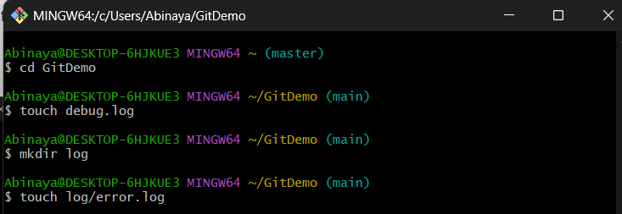

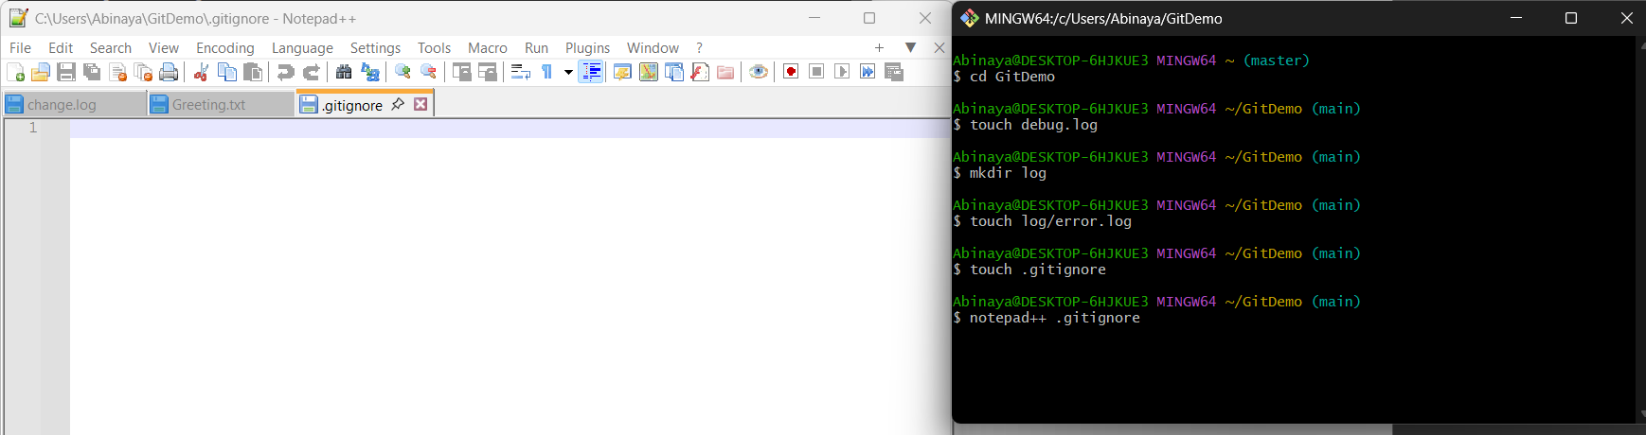

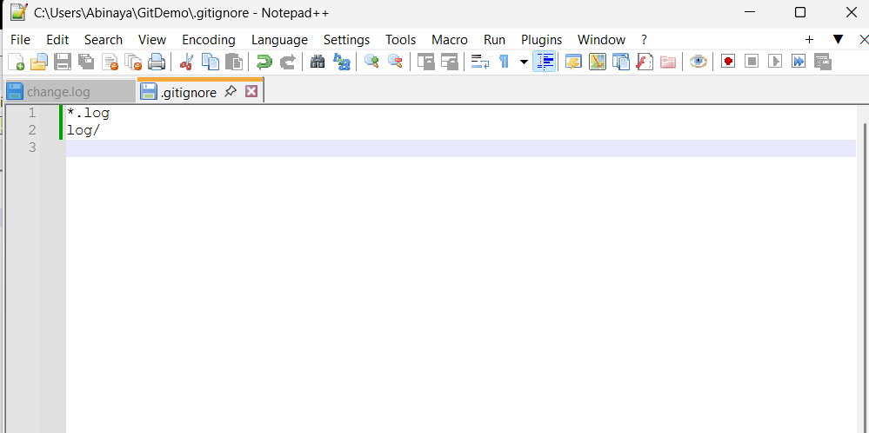

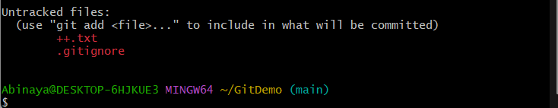

Log files and folder are ignored

